Phase A: Concept and Technology Development

Brandon Hickey

9/22/2023

Following: <https://www.eng.auburn.edu/~dbeale/ESMDCourse/Chapter2.htm>

# Purpose

To determine the feasibility and desirability of possible systems.

# Trade-Studies

So as part of this project, we have decided on 5 potential options in terms of aircraft frame and engine design. While there are many different options that exist, these options stem from a personal preference and potential to satisfy mission objectives while staying within constraints.

## Option #1: Twin-Boom Frame with Single Center-mounted Engine, Mid/Low wing

The while looking at historical twin-boom frames, I found that I enjoyed the sleek look and the potential ruggedness of a connected tail. Looking at available RC twin-boom aircrafts in the market, they are often design as pusher aircraft rather than puller. This means that the engine would be mounted to the rear of the main fuselage, between the tails. This would create a hard limit in terms of motor propellor size combinations. It would allow for a much thinner and therefore lighter tail section. However, it creates an added complexity of two rudder systems and a connected elevator. The result would be increased wiring and having to make the tails capable of holding the necessary control servos or routing a rod from the fuselage along the booms to the rudder and elevator. Mounting for components should not be an issue and given a large enough wingspan I will likely not run into issue with other constraints like payload.

## Option #2 Twin-Boom Frame, with Two Wing mounted engines, , Mid/Low wing

This was closer to more historical frames with two propellor engines mounted on each boom. This would increase my maximum thrust at the cost of some additional mass for housing the engines and electrical components. The complexity would be a little higher here than Option #1 due to the strength considerations for the motor but would allow for more varied combinations of motor/propellors depending on distance from and objects the propellor could impact. Still contains the complexity of the tail control surface and design.

## Option #3 Trainer style, High-Wing, Single Engine

This is a basic model used for many beginners in remote-controlled fixed-wing aircraft. The high-wing design and potential dihedral provides more stability in flight and would have the motor mounted to the nose, providing thrust in line with the center of mass and low wiring complexity to connect motor to control. It does have the issue of needing to angle the motor (Thrust angle) to counter aircraft tendencies. With a single engine we will need to be more cautious of our weight and payload constraint, however the ease of designing and manufacturing with less required strength on the wings than a multi-engine frame would offset this.

## Option #4: Trainer Style, High-wing, Two wing-mounted engines

This would have the same style as Option #3, with added complexity due to mounting engines to the wings. This would increase our maximum payload and T/W. However, like Option #2, it adds additional considerations to the strength of the wings and wiring complexity. It would also allow for potential flight while on a single motor given a potential failure. Removes the need for thrust angle as we can spin propellors opposite directions.

## Trade Study Result

|  |  |  |  |  |  |
| --- | --- | --- | --- | --- | --- |
| Criteria | Weight | Twin Boom 1E | Twin Boom 2E | Trainer 1E | Trainer 2E |
| Score | Score | Score | Score |
| Expected Ease of Designing | 15 | 6 | 3 | 12 | 9 |
| Expected Ease of Manufacturing | 10 | 6 | 4 | 8 | 6 |
| Expected Ease of assembling | 15 | 6 | 3 | 9 | 6 |
| Durability/Rigidity | 10 | 8 | 6 | 8 | 6 |
| Maneuverability | 10 | 8 | 10 | 6 | 6 |
| Aesthetic/Personal Taste | 5 | 3 | 4 | 2 | 4 |
| Stability | 15 | 9 | 9 | 12 | 12 |
| Weight w/o Payload | 10 | 8 | 6 | 8 | 6 |
| Payload Capacity | 10 | 4 | 6 | 4 | 6 |
| Total | 100 | 58 | 51 | 69 | 61 |

Based on an overview of the frame type, we can conclude that for at least a first full attempt, the trainer is the most viable option for success. While it does not contain as much potential thrust as the multi-engine frames, its ease of design, manufacturing, and assembly, along with natural stability, makes it a clear choice. Moving forward, we will perform our reviews and development with the Single-Engine High-Wing Trainer.

# Systems Engineering Functions

Here I will attempt to go through each function and attempt to perform them at this stage.

## SE Function 1: Mission Objectives and Constraints

The goal of this project is to develop, design, and test a 3D printed remote-controlled aircraft capable of decent flight time and potential for payload. Due to the nature of the project, goals and requirements at this stage are ambiguous and lack many hard-set constraints. I will go through and list the current objectives and constraints and attempt to provide a range of required performance to then use moving forward in Phase A – Concept and Technology Development

## SE Function 2: Derived Requirements Development

### Project Objectives and Constraints List

* The aircraft frame should be made from a 3D printable material. Using personal printers, individual part sizes should not exceed 200mm x 200mm x 200mm. This is to limit the potential for print failure as the larger pieces result in more time to print. Also, as prints move from the center of the build plate, issues arising from leveling and bed adhesion become more common.
* The aircraft wingspan should be less than 1500mm. This is a personal decision, but I believe that increasing the aircraft leads to higher costs in terms of material and electronics and will become more costly to continue the project should multiple failures occur during testing phases. The minimum wingspan size will likely be dictated by the desired performance of the aircraft in terms of payload size and aircraft weight.
* The vehicle must function on either 2S or 3S lipo batteries. I would prefer to be able to utilize a 2S due to the lighter weight. I, however, understand that given the weight of the aircraft I may need a higher voltage.
* Looking at some forums of RC Plane flyers, for a beginner flyer I am looking at a cruising speed of roughly 20-30 mph or 9 – 13.5 m/s. This should provide a low minimum runway distance. The slow speed should also ensure that I am able to watch and critique the performance of the aircraft during passes.
* So, I do not have any desired weight limits, however I believe something less than 1,000 grams would be good in terms of manufacturing time. It will give me a targeted motor thrust output. I will look for a Thrust to weight ratio of between 0.2 and 0.5. At my limit, that would require a motor thrust between 200 and 500 grams.
* I am looking for a flight time of at least 10 minutes, this is a minimum, but my preferred range would be around 20 minutes.
* The aircraft should be operable with a payload that will include a more advanced flight controller such as a Navio2. While I do not have the exact weight of the flight controller currently, I would estimate it will be no more than 300 grams.

### Identified Objectives and Constraints

* Made from 3D Printed Material.
* Individually printed pieces should not exceed 200mm x 200mm x 200mm.
* Aircraft wingspan to not exceed 1500mm.
* Electrical voltage will be either 2S or 3S Li-Po
* Aircraft Cruising speed: 9 – 13.5 m/s
* Vehicle weight less than 1,000 grams
* Thrust to weight ratio: 0.2 – 0.5.
* Motor Thrust: 200 – 500 grams
* Capable of flying for at least 10 minutes, 20 is preferred.
* Capable of carrying an extra 300-gram payload.

## SE Function 3: Architectural Design Development

## Power Subsystem

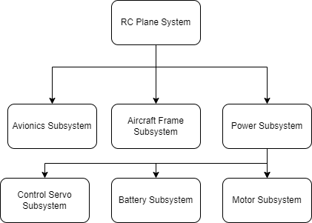

## Avionics Subsystem

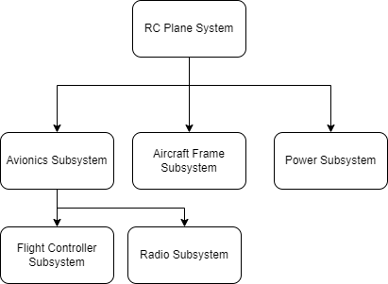

## Aircraft Frame Subsystem

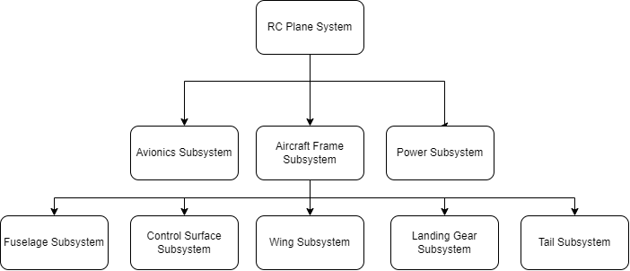

## SE Function 4: Concept of Operation

## SE Function 8: Technical Resource Budget Tracking

Expected Budgets we plan to track during the project:

* Mass budget, this will help us keep track of the breakdown of object weights and where we might be able to trim potential issues.
* Cost Budget, keeping track of costs is important.
* Power Budget, this might be good to keep track of our power consumption to give a good breakdown of flight time estimation.

## SE Function 9: Risk Management

We will perform the following in the project.

* Seek and Identify risks.
* Determine risk severity and effect.
* Develop methods of risk mitigation

## SE Function 10: Configuration Management and Documentation

All content except Fusion360 files will be stored in GitHub. Project management will also be done through GitHub to maintain traceability. If Fusion360 files are added, they can be uploaded daily with provided changes.

## SE Function 11: System Milestone Reviews and Reports

As I am the stakeholder, my reviews are kind of to myself? I can mark milestones using GitHub to identify major areas of the project such as finishing phases and scheduled testing dates.